Batyr Charyyev

CS791-hw3

Question 1.

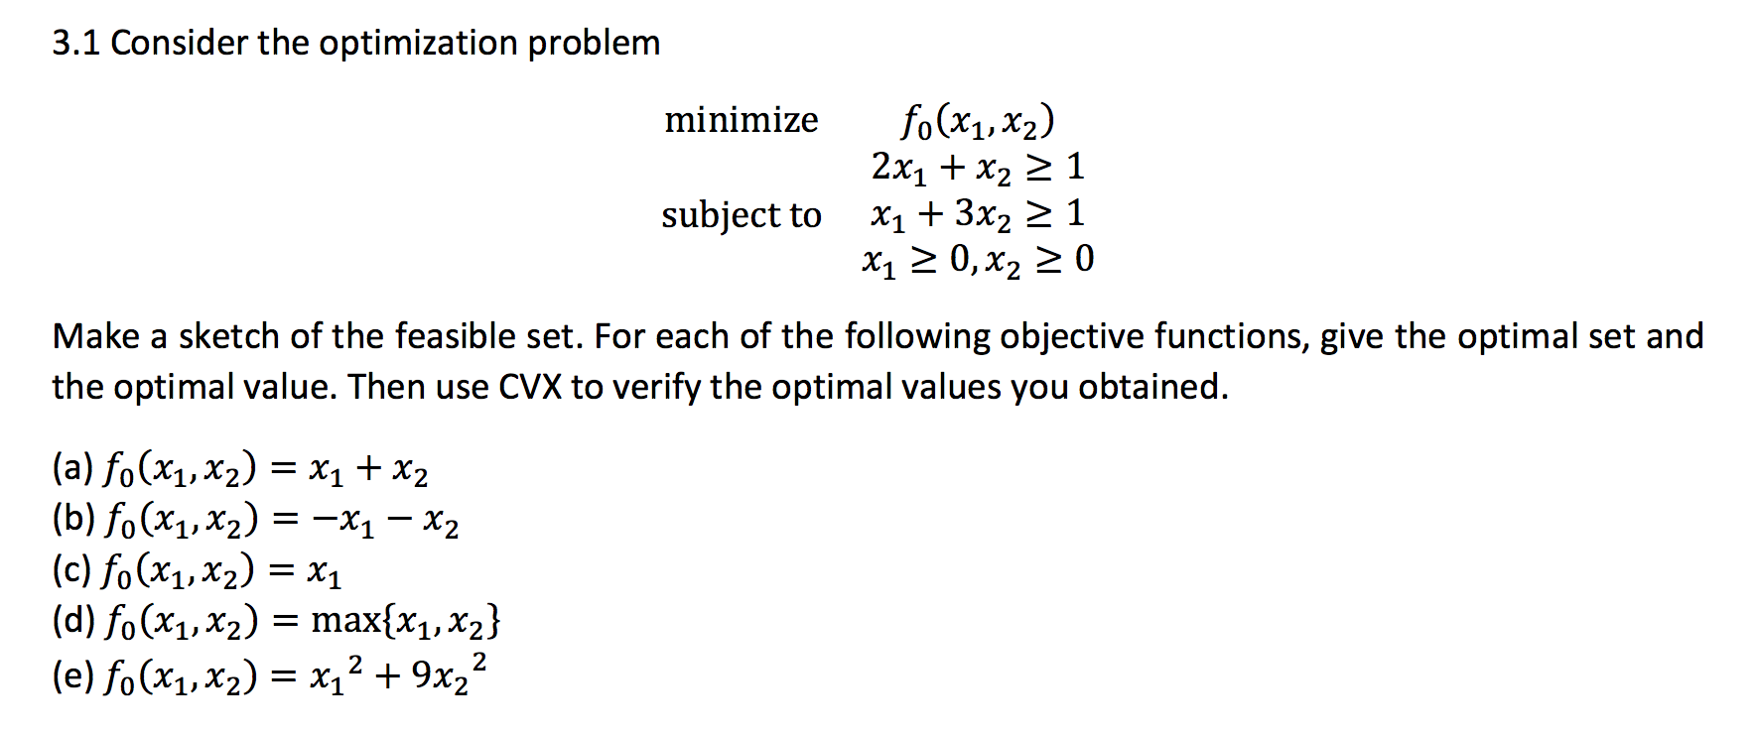

Answer:

Feasible set is set of point which are in domain of f0 and satisfies to our constraint functions. So for this problem, convex hull of (0, ∞), (∞,0), (0,1), (1,0), (2/5,1/5) is our feasible set.

1. p\* = (2/5, 1/5)
2. p\* = -∞ (unbounded below)
3. Since here our object function’s output is only x1 even if it takes x2 as input, we have set of optimal values where our x2 can be any number in domain.

So Xopt = {(0,x2) | x2 ≥1}

1. p\* = (1/3,1/3)
2. p\* = (1/2,1/6)

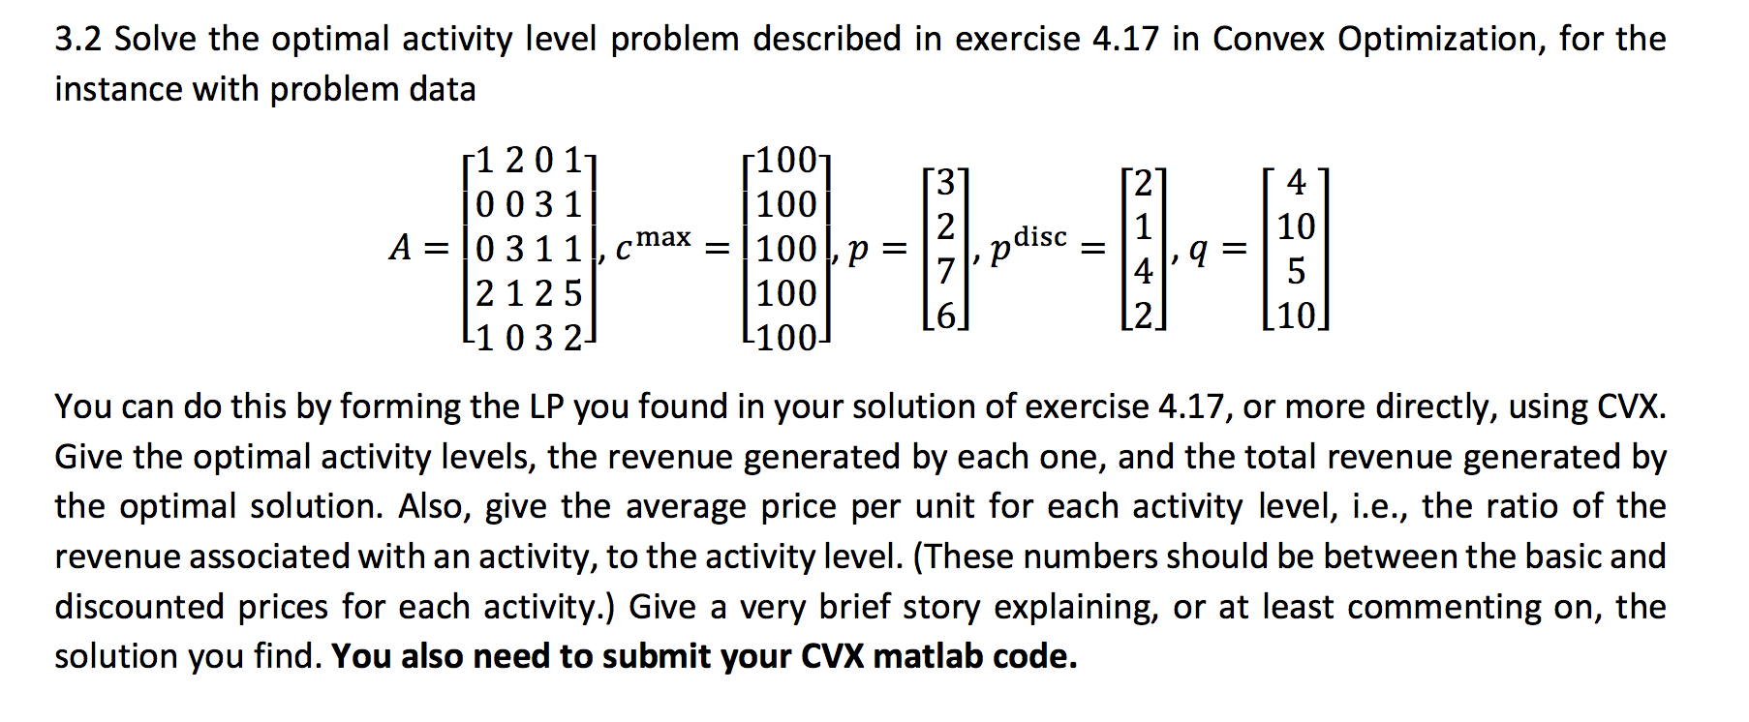 Question 2.

Answer:

I was not sure how to submit CVX code, so here is the screenshot. To run it on Matlab you should install CVX.

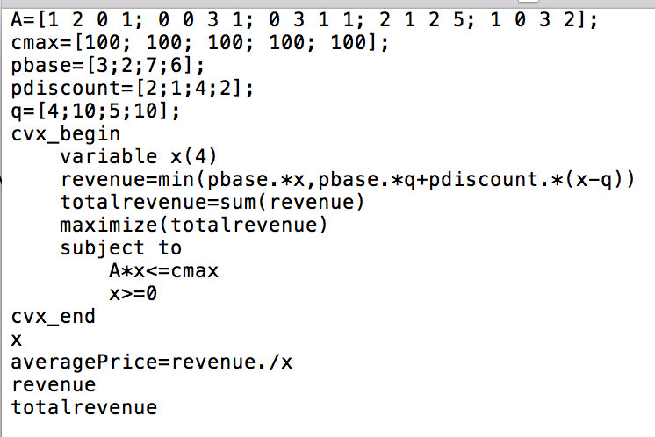

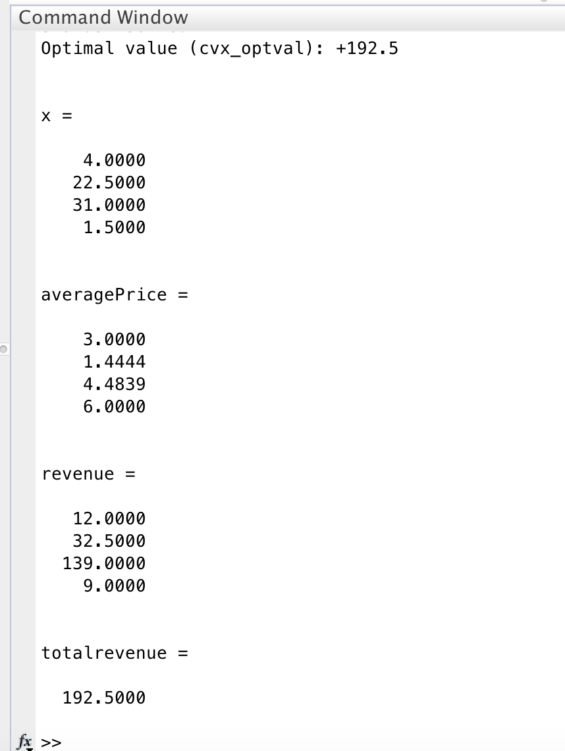

We can see that highest revenue is 3rd level and lowest revenue is 4th level. Third level has highest basic price, discount price and highest activity level. So its contribution to total revenue is highest. 4th level also has high basic price however, there is a considerable amount of difference in basic price and discount price so it has less contribution to total revenue.

Question 3

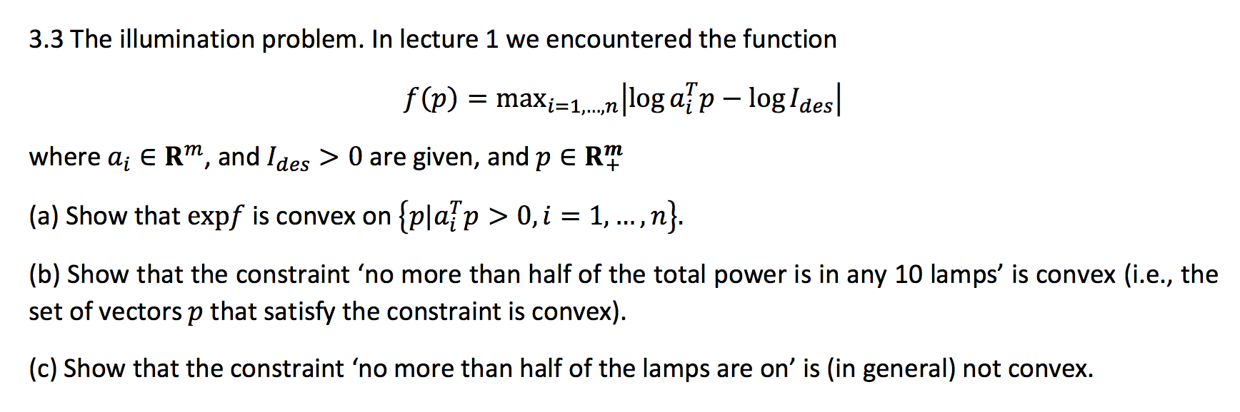

Answer:

../Screen%20Shot%202018-03-25%20at%209.25.52%20PM.png

1. let’s say X =

we know X is convex (affine function), since Ides is positive log(X/Ides) is also convex, since it is convex, maximum of convex function is also convex so max(log(X/Ides)) is convex.

Since exp is increasing function exp of convex function is convex, so exp(f) is convex.

1. From lecture notes we know that feasible set of convex problem is convex. Since p is set of vectors that satisfy the constraint we know that it is in feasible set and since our problem is convex we can conclude that “no more than half of the total power is in any 10 lamps” is convex.
2. ../Screen%20Shot%202018-03-25%20at%2011.09.11%20PM.png“No more than half of the lamps are on” means that “at least half of the lamps have no contribution to total power”. This constraint contradicts with so it is not convex.